1. **What is the total amount spent in each category for over all 2024?**

**Syntax:**

select sum(amount) as total_amount_Groceries from expense_year where category = 'Groceries';

Groceries:  
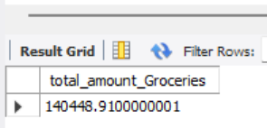

Health & Medicine

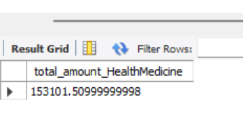

Investment

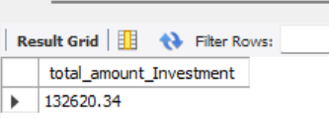

Loan amount

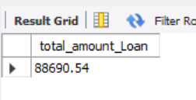

School fees

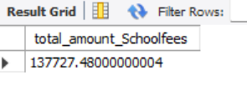

Shopping

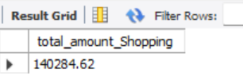

Subscription

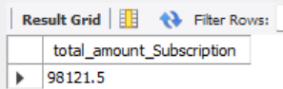

1. **What is the total amount spent using each payment mode?**

**Syntax:**

select sum(amount) as total_amount_Cash from expense_year where Payment_Mode = 'Cash';

Cash:

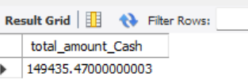

Credit card

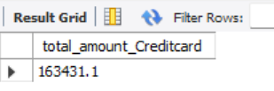

Debit card

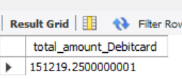

Netbanking

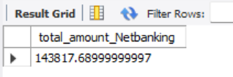

UPI

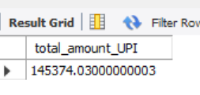

Wallet

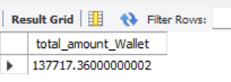

1. **What is the total cashback received across all transactions?**

**Syntax:**

select sum(cashback) as total_amount_cashback from expense_year;

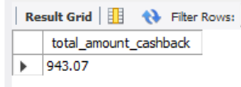

1. **Which are the top 5 most expensive categories in terms of spending?**

**Syntax:**

select category,sum(amount) as total_amount from expense_year group by category order by total_amount desc limit 5;

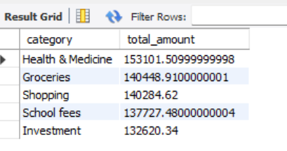

1. **How much was spent on transportation using different payment modes?**

**Syntax:**

**select sum(amount) as amount_UPI from expense_year where payment_mode='UPI' and discription='Transportation';**

**select sum(amount) as amount_Creditcard from expense_year where payment_mode='Credit card' and discription='Transportation';**

**select sum(amount) as amount_Netbanking from expense_year where payment_mode='Netbanking' and discription='Transportation';**

**select sum(amount) as amount_Wallet from expense_year where payment_mode='Wallet' and discription='Transportation';**

**select sum(amount) as amount_Cash from expense_year where payment_mode='Cash' and discription='Transportation';**

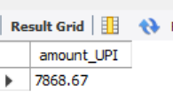

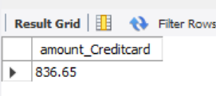

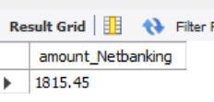

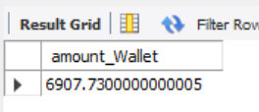

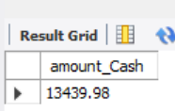

1. **Which transactions resulted in cashback?**

**Syntax:**

select distinct payment_mode as transaction from expense_year where cashback > 0;

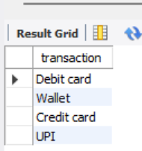

1. **What is the total spending in each month of the year?**

**Syntax:**

select sum(amount)as Jan_spending from expense_year where months='Jan';

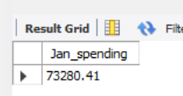

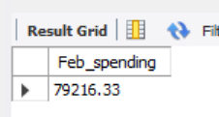

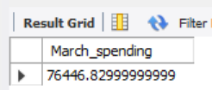

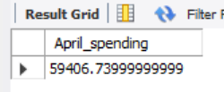

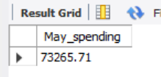

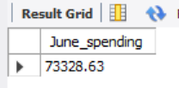

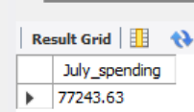

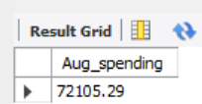

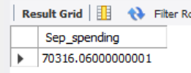

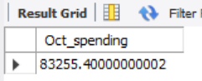

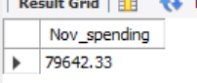

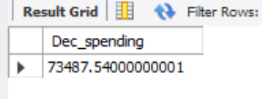

1. **Which months have the highest spending in categories like "Travel," "Entertainment," or "Gifts"?**

**Syntax:**

select months,Discription,sum(amount) as total_spending from expense_year where discription in('Toys/Gifts Purchase','Transportation','Movie charge','Subscription for Hotstar','Subscription for Netflix') group by months,discription order by total_spending desc limit 1;

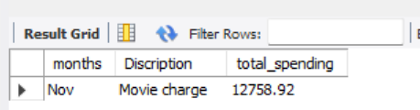

1. **Are there any recurring expenses that occur during specific months of the year (e.g., insurance premiums, property taxes)?**

**Syntax:**

select category,months,count(amount)as recurrence_count from expense_year group by months,category having recurrence_count > 1 order by months,category;

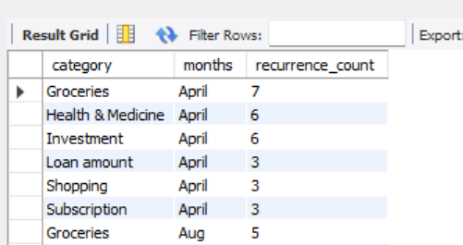

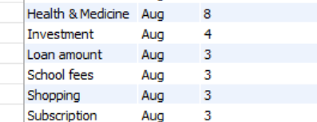

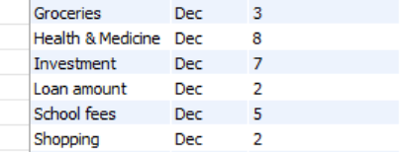

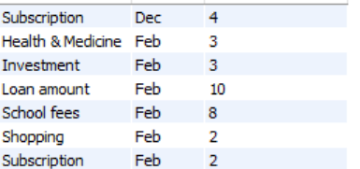etc..



1. **How much cashback or rewards were earned in each month?**

**Syntax:**

select months,sum(cashback)as cashback from expense_year where cashback>0 group by months;

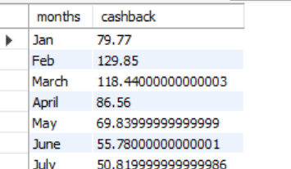

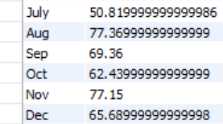

**11.How has your overall spending changed over time (e.g., increasing, decreasing, remaining stable)?.**

**Syntax:**

**WITH monthly_spending AS (**

**SELECT**

**months,**

**SUM(amount) AS total_spending**

**FROM**

**expense_year**

**GROUP BY**

**months**

**),**

**spending_change AS (**

**SELECT**

**months,**

**total_spending,**

**LAG(total_spending) OVER (ORDER BY CASE WHEN months = 'Jan' THEN 1 WHEN months = 'Feb' THEN 2 WHEN months = 'March' THEN 3 WHEN months = 'April' THEN 4 WHEN months = 'May' THEN 5 WHEN months = 'June' THEN 6 WHEN months = 'July' THEN 7 WHEN months = 'Aug' THEN 8 WHEN months = 'Sep' THEN 9 WHEN months = 'Oct' THEN 10 WHEN months = 'Nov' THEN 11 WHEN months = 'Dec' THEN 12 ELSE 13 END ASC) AS previous_month_spending**

**FROM**

**monthly_spending**

**)**

**SELECT**

**months,**

**total_spending,**

**previous_month_spending,**

**(total_spending - previous_month_spending) AS change_in_spending**

**FROM**

**spending_change**

**GROUP BY months ORDER BY CASE WHEN months = 'Jan' THEN 1 WHEN months = 'Feb' THEN 2 WHEN months = 'March' THEN 3 WHEN months = 'April' THEN 4 WHEN months = 'May' THEN 5 WHEN months = 'June' THEN 6 WHEN months = 'July' THEN 7 WHEN months = 'Aug' THEN 8 WHEN months = 'Sep' THEN 9 WHEN months = 'Oct' THEN 10 WHEN months = 'Nov' THEN 11 WHEN months = 'Dec' THEN 12 ELSE 13 END ASC;**

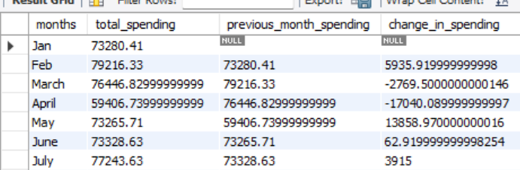

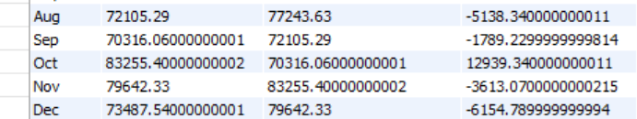

1. **What are the typical costs associated with different types of travel (e.g., flights, accommodation, transportation)?**

**Syntax:**

select Avg(amount),discription from expense_year where discription='Transportation';

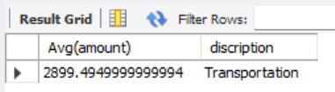

1. **Are there any patterns in grocery spending (e.g., higher spending on weekends, increased spending during specific seasons)?**

**Syntax: For seasonal spending like Diwali and New year**

select months,category,sum(amount)as Grocery_amount from expense_year where category= 'Groceries' group by months,category order by grocery_amount desc;

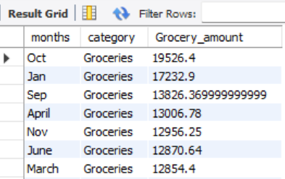

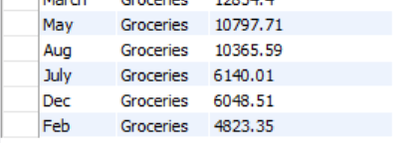

**Syntax: For weekdays(Sunday was spent a lot)**

select DAYNAME(date) as DayName,category,sum(amount)as Grocery_amount from expense_year where category= 'Groceries' group by DayName,category order by grocery_amount desc;

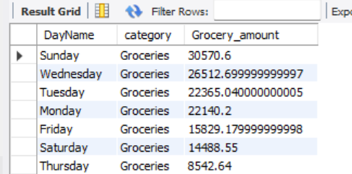

1. **Define High and Low Priority Categories?**

**Syntax:**

select category,sum(amount)as total_spent from expense_year group by category order by total_spent desc;

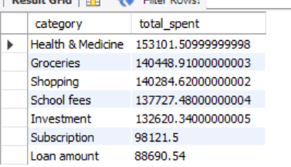

Here high priority on Health & Medicine where as low priority on Loan amount.

1. **Which category contributes the highest percentage of the total spending?**

**Syntax:**

SELECT category, (SUM(amount) / (SELECT SUM(amount) FROM expense_year)) * 100 AS percentage_of_total FROM expense_year GROUP BY category ORDER BY percentage_of_total DESC LIMIT 1;

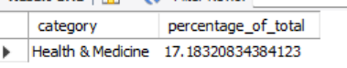

**16.What is the total amount saved at overall year?**

**Syntax:**

select sum(amount)as Saving_amount from expense_year where Category in('Loan amount','Investment');

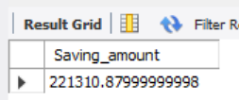

**17.Average amount spent per month?**

**Syntax:**

SELECT SUM(amount) / 12 AS Avg_per_month FROM expense_year;

